Setting Up Application Environment

Create IBM Cloud Account

|  |  |
| --- | --- |
| Date | 24 Oct 2022 |
| Team Id | PNT2022TMID33344 |
| Project Name | News Tracker Application |

# Step 1:

Type or click the below link in the browser ***https:***[***//ww***](http://www.ibm.com/academic/home)***w***[***.ibm.com/academic/hom***](http://www.ibm.com/academic/home)***e***

# Step 2:

Click the register icon.

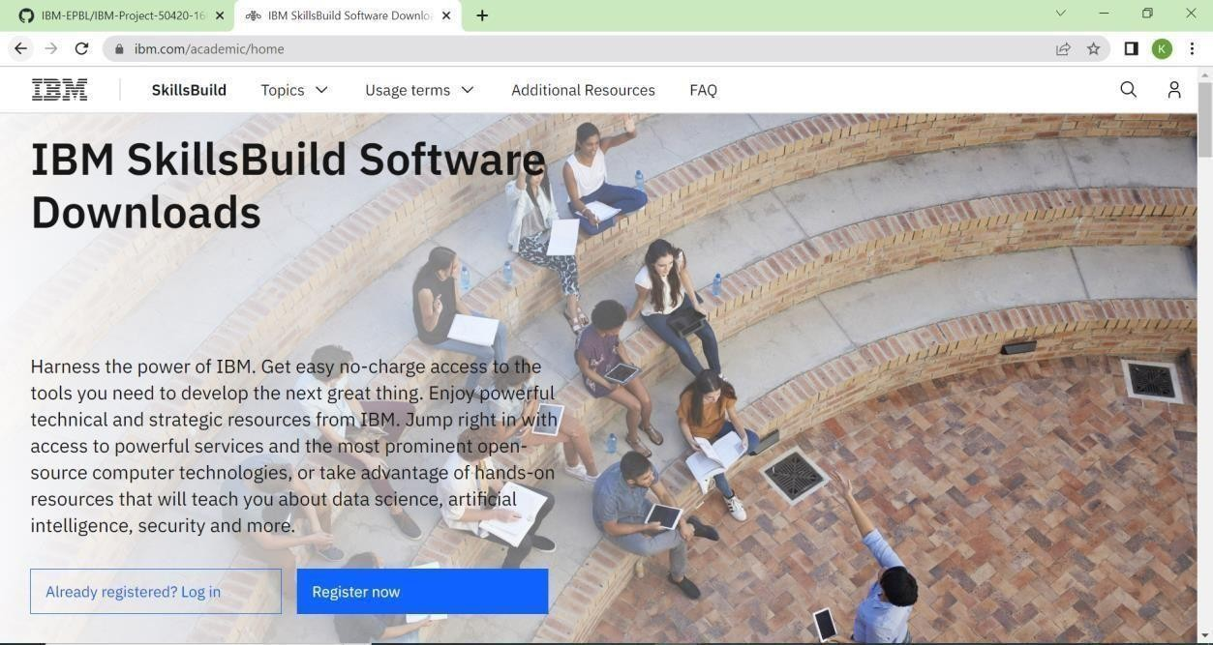

# Step 3:

Already you got SI EMAIL and SI PASSWORD from your IBM student login.

Login to your web mail account. Wait for 7-digit verification code in your web mail:

***https://sg2plmcpnl496936.prod.sin2.secureserver.net:2096/***

# Step 4:

Get a 7-digit verification code in webmail, then go to the registration page and enter the verification code.

# Step 5:

Now, you have successfully created the IBM Cloud Account.

# Step 6:

Go to IBM Cloud login page: ***https: //cloud.ibm.com/login*** ,then enter your IBM Id and Password.

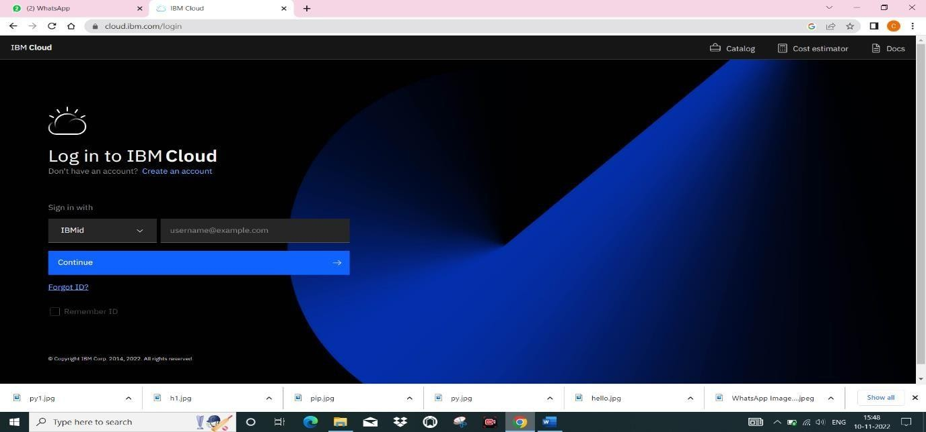

# Step 7:

Finally, we can access the IBM cloud account!